**MulliganStats User Manual**

A program that finds the statistics of a mulligan appearing.

Cachary Tolentino

CSCI-3327

**Table of Contents**

**Software Description3**

Detailed Description3.1

System Requirements3.2

**Installation Guide4**

**Class Overview6**

**Software Description**

A program that finds the statistics of finding a mulligan.

**Detailed Description**

A simple program that emulates a Pokemon deck with Pokemon. The goal of the program is to find the statistics of having a mulligan hand (no pokemon on the hand).

**System Requirements**

* A working device, primarily a desktop or laptop
* An IDE (ex: VSCode, Eclipse, etc…)
* Java JDK (Ver. 17 & up) & JRE (SE 17 & up)

**Installation Guide**

To begin using the RareCandyStats Software, first download “Card.java”, “Mulligan.java”, and “TestMulligan.java” (optional).

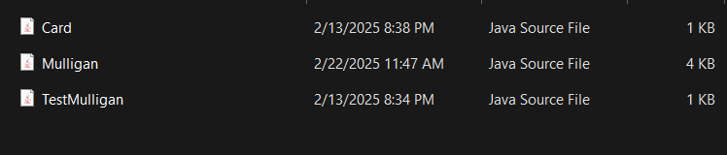

Once downloaded, you can either move the files to your project folder or directly open it in your desired IDE (we will be using VSCode in this tutorial). Open your IDE and open the folder containing the files.

Once opened, it should look similar to the following image.

From here you can simply start using the classes as you would for any Java classes. But if you wanted to quickly test or see the results using the code then open the “TestMulligan.java” file and run it. The output should look similar to the following image.

**Class Overview (Notable Code)**

**mulliganProbabilityPerPokemon Function**

The function will run for a set amount of trials per amount of Pokemon (0 - 61). Per trial, a mulligan deck will be made (not guaranteed to have a mulligan hand). It will then create the hand (7 cards). Finally, after checking if the hand contains no Pokemon, if so then it is considered a mulligan.

